DriverPass System Design Document
CS 255 Project Two
DriverPass needs a web-based system that supports driver training, two-hour driving appointments, customer progress, and administrative reporting. This design connects customer accounts, training packages, practice tests, instructors, vehicles, and reservation history. It follows the client’s interview requirements and uses a managed cloud environment so customers and staff can access the system from computers and mobile devices.

Design Scope
Customers and the secretary can enter student information and manage appointments. Liam, the owner, can review reports and disable a package for new registrations. Ian, the IT officer, manages access, password resets, and maintenance. Driving instructors record lesson times and comments. The DMV is an external source of updated rules, policies, and sample questions.
The current release supports disabling packages. Adding or removing entire software modules is a future development task, as clarified in the interview. Offline access means downloaded reports that can be reviewed in Excel; changes to the central system require an internet connection.

Training Packages
Package One provides six driving hours, scheduled as three two-hour sessions.
Package Two provides eight driving hours, scheduled as four two-hour sessions, plus an in-person lesson about DMV rules and policies.
Package Three provides twelve driving hours, scheduled as six two-hour sessions, the in-person lesson, and online classes with practice tests.

Reservation Rules
Every lesson is two hours long and links one customer to one instructor, one vehicle, and an enrollment. The initial fleet has ten cars. A proposed booking checks remaining package hours and overlapping reservations. Pickup and drop-off locations must match. Creation, modification, and cancellation record the acting user and time for activity reports. As a design rule, canceled reservations release their reserved hours; completed lessons remain counted against the package.

Source
Requirements are drawn from the supplied CS 255 DriverPass Interview Transcript (Southern New Hampshire University, n.d.). Class names, validation flows, and infrastructure controls are proposed design choices implementing those requirements.

UML Diagrams

UML Use Case Diagram
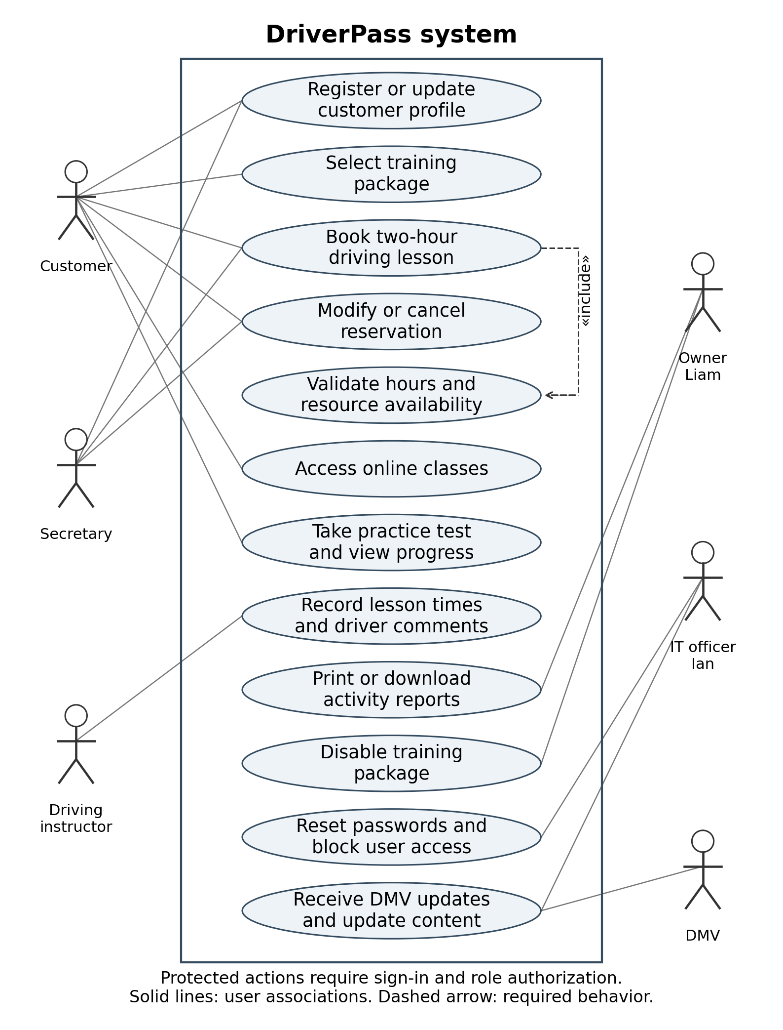
Figure 1. DriverPass user functions and system boundary. The customer’s online learning access depends on the selected package. Booking includes checking package hours and resource availability. The instructor is a user role inferred from the requirement to record driver comments and lesson times.

UML Activity Diagrams

Activity One Book a Driving Lesson
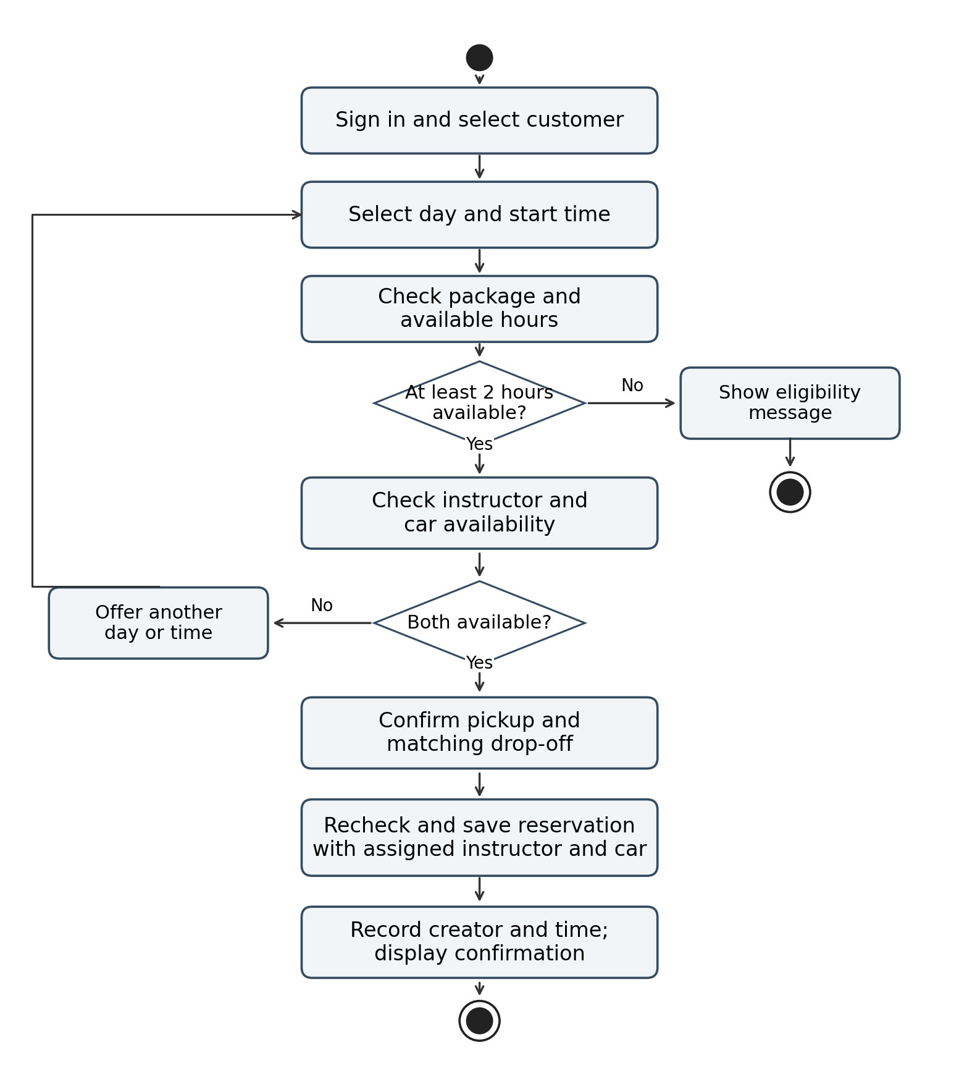
Figure 2. Customers book online; the secretary follows the same workflow on a customer’s behalf. The system rejects insufficient hours and offers other times when resources are unavailable. The final save rechecks availability to prevent two simultaneous requests from booking the same instructor or car.

UML Activity Diagrams

Activity Two Take a Practice Test
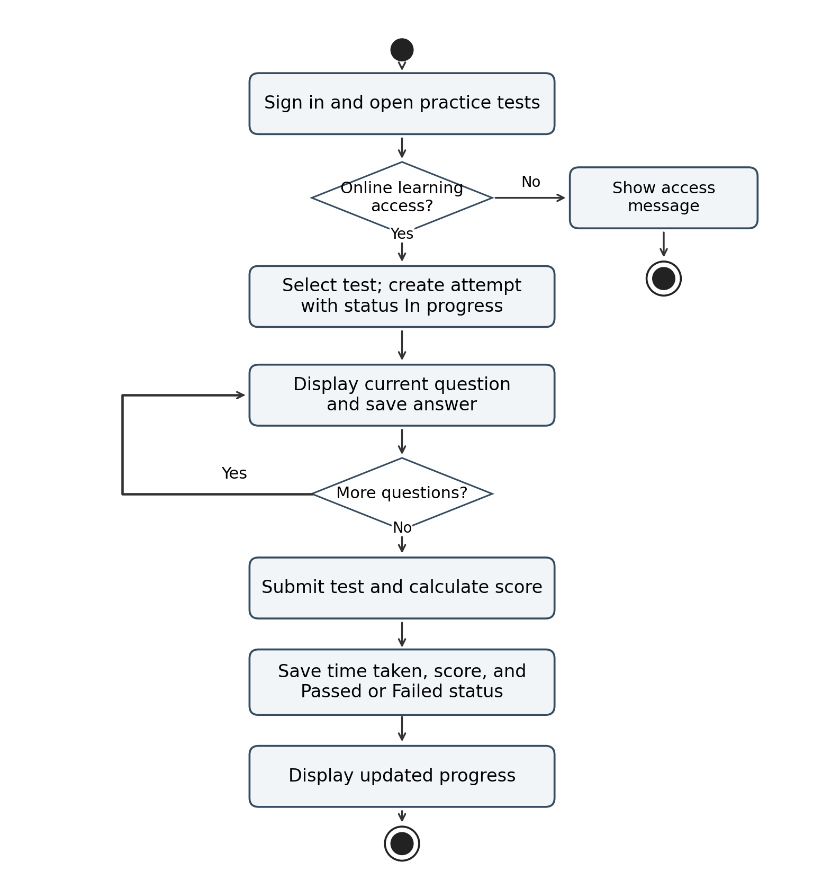
Figure 3. Online testing is available through an eligible enrollment. Tests begin with In progress status and end with Passed or Failed status based on a configured threshold. The transcript does not specify that threshold. A test with no attempt appears as Not taken in the progress view.

UML Sequence Diagram

Book a Driving Lesson
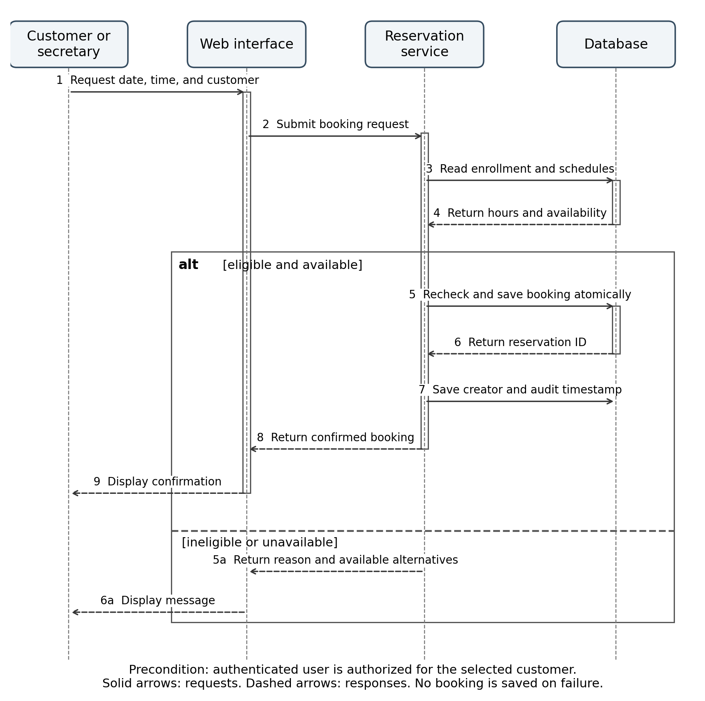
Figure 4. The interface submits the booking to the reservation service, which reads eligibility and schedules from the database. A successful request saves the reservation and its audit entry in one transaction. Failure returns a reason without saving a reservation. Pickup and drop-off validation occurs before the save.

UML Class Diagram

Account and Reservation View
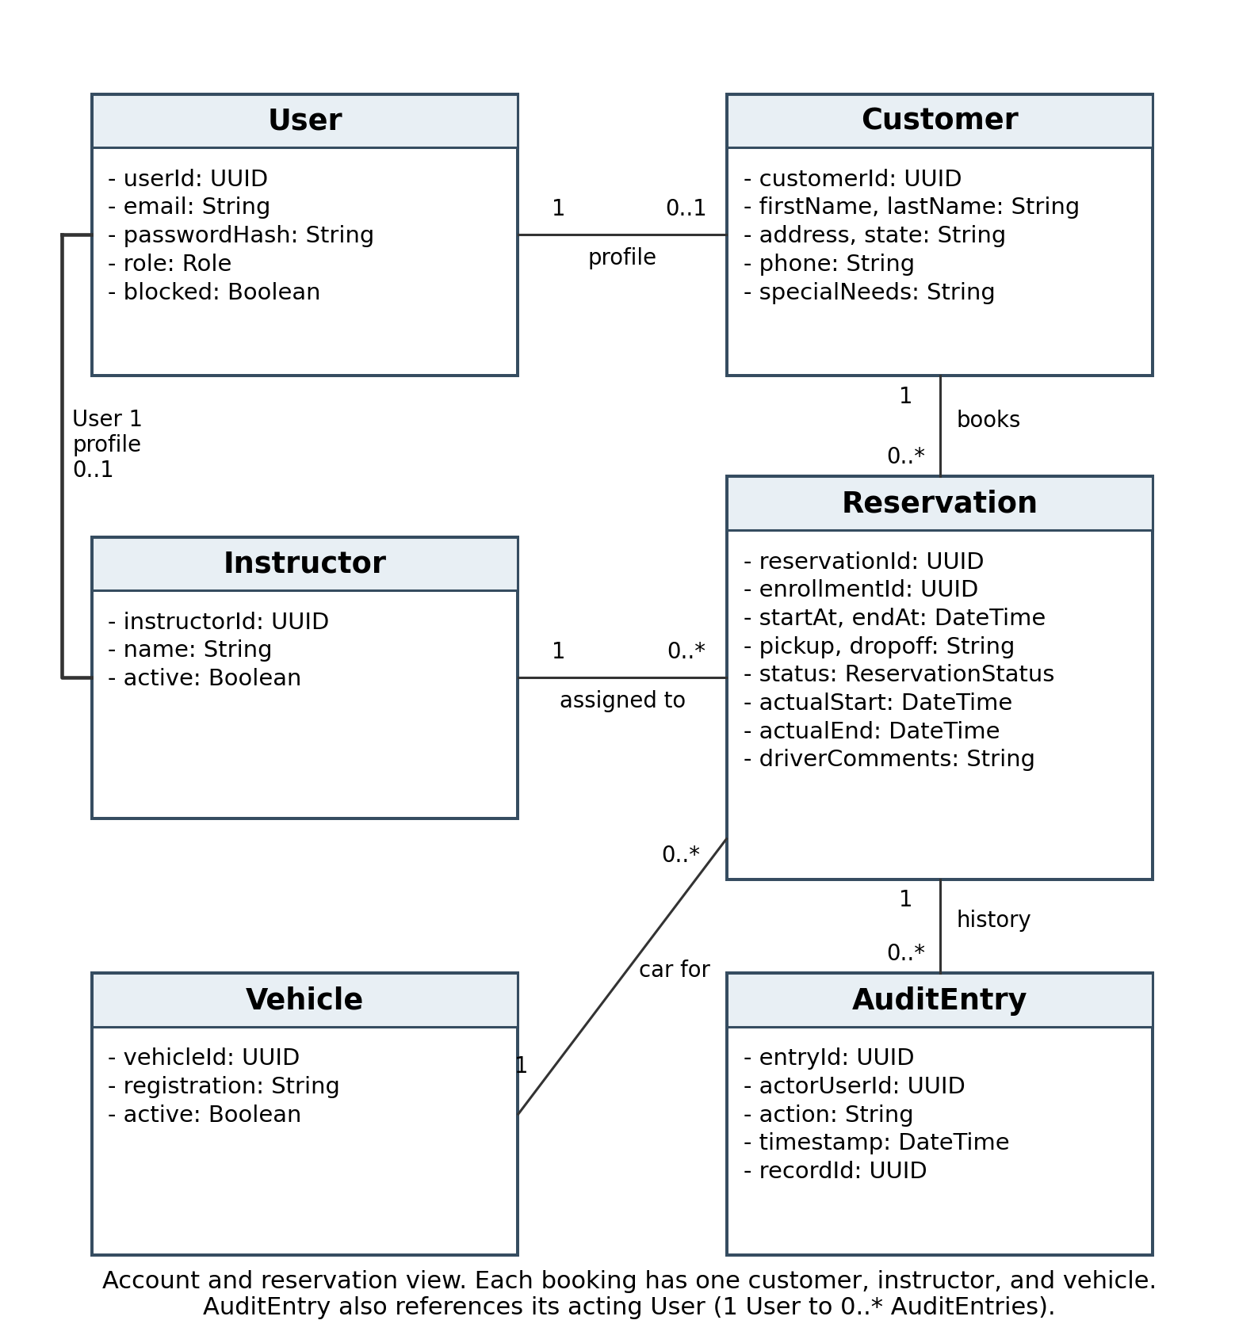
Figure 5a. Classes contain attributes; methods are omitted as allowed by the template. User.role controls access for customers, secretary, owner, IT officer, and instructors. AuditEntry stores the actor as well as the affected record. Instructor and customer profile records each link to a User account.

UML Class Diagram

Training and Assessment View
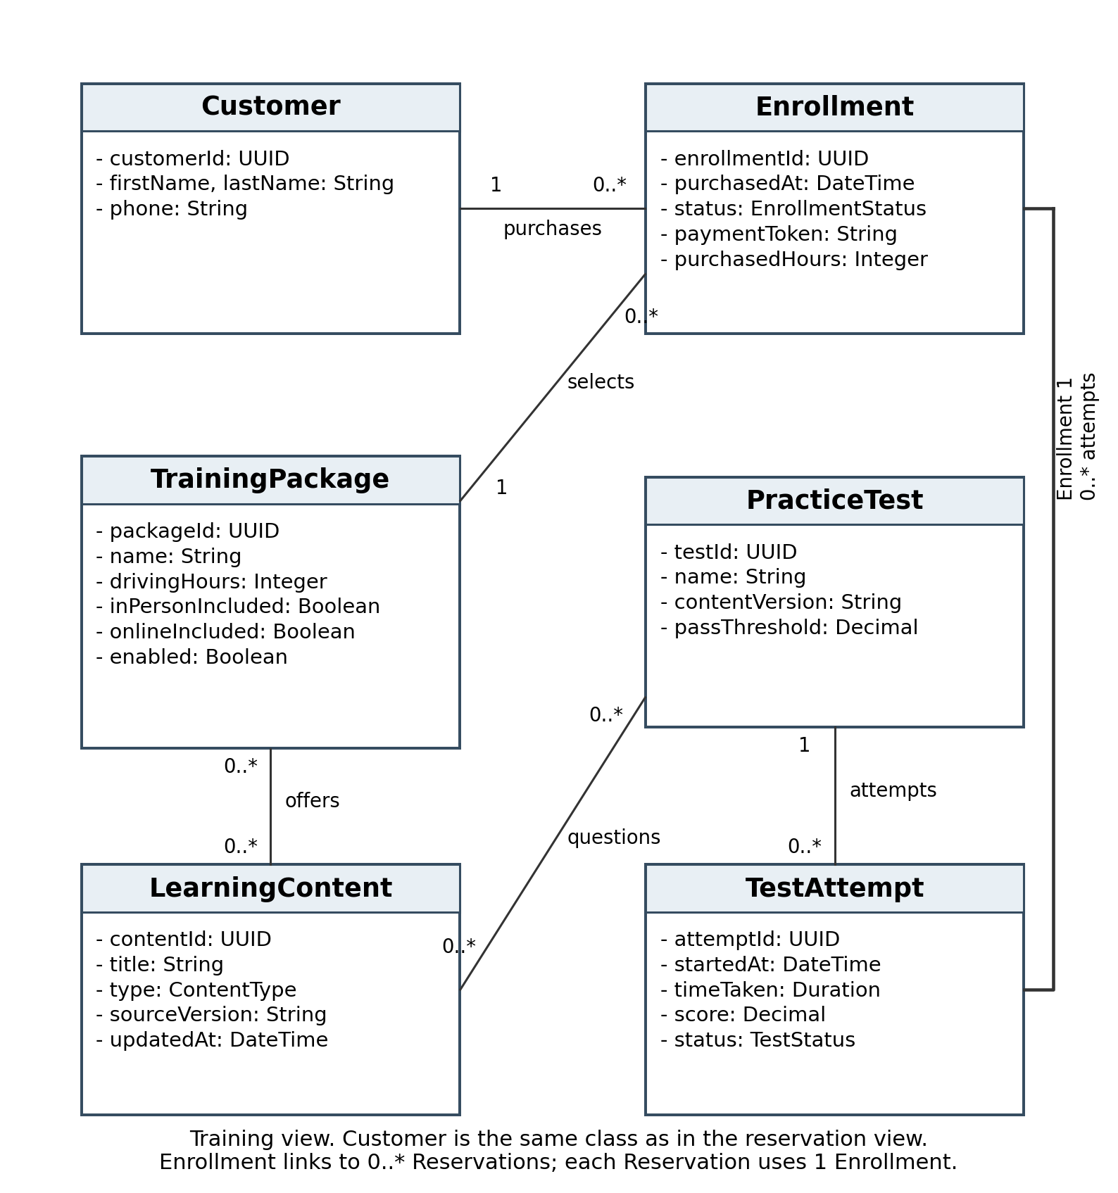
Figure 5b. This view continues the same class model. Enrollment links a customer to a selected package and its purchased hours. Available hours are derived from purchased hours minus completed and active reserved lesson hours. TestAttempt stores the progress fields requested by Liam. Content versions identify which DMV material was used.

Technical Requirements

Hardware and Infrastructure
Customers and staff need an internet-connected computer, tablet, or phone with a web browser. Office staff need workstations and a printer for activity reports. Liam needs spreadsheet software such as Excel to review downloaded data. No specialized customer hardware or local application installation is required.
Host the application and centralized database in a managed cloud environment, matching Ian’s preference. Separate the browser interface, application services, and database. Store lesson records, accounts, test attempts, and audit history centrally; store learning materials and profile images in protected cloud file storage. The provider should support automated backups, recovery, security updates, and monitoring. Backup frequency, retention, and recovery targets are implementation settings to agree with DriverPass.

Software and Data Management
Use a responsive web interface with registration, sign-in, student progress, scheduling, and contact pages. The progress page shows test name, time taken, score, and status, along with driver notes, actual lesson times, contact information, special needs, and authorized profile photos. Customer registration collects first name, last name, address, state, phone, and pickup and drop-off information. Include email for account recovery and communication, consistent with the supplied interface sketch.
Use a relational database to enforce links between customers, enrollments, instructors, cars, appointments, and test attempts. Apply transactions when creating, changing, or canceling reservations. Check overlaps for the entire two-hour interval, not only the starting time. Preserve reservation history instead of deleting canceled records. Disabling a package prevents new registrations while preserving existing enrollments.

Access and Reporting
Enforce permissions on the server. Customers access their own records; the secretary manages customer profiles and bookings; instructors view assigned lessons and record notes; Liam reviews reports and disables packages; Ian administers accounts and maintenance. Offer automatic password recovery and IT-assisted resets. Blocking an account prevents further access without erasing its historical actions.
Generate printable activity reports showing who created, canceled, and last modified each reservation. Offer Excel-compatible downloads, such as CSV, for offline review. Downloaded copies do not modify the central records or synchronize automatically. All edits to live system data require an online connection.

Technical Requirements

Security and Payment Handling
Use encrypted connections, protected cloud storage, password hashing, and server-side authorization. Limit access to customer contact information and special needs by role. Track administrative changes and reservation actions with timestamps and user identifiers. Keep backups separate from the live database and verify that records can be restored.
The interview requests credit card details during telephone registration. The proposed implementation uses a payment provider’s protected entry form and retains only a payment token and transaction reference in DriverPass. Card numbers and security codes are not attributes in the DriverPass database. Confirm the provider and telephone payment process with the client during implementation.

DMV Updates and System Maintenance
Provide a connection or approved import workflow for DMV rules, policies, and sample questions, and notify authorized staff when updates arrive. The transcript does not identify an available DMV interface, so confirm the integration method before implementation. Store source versions and update dates, review incoming content, and publish approved material to classes and practice tests.
Ian needs administrative tools to maintain the system and control access. Use centralized logging and monitoring for service failures, unsuccessful updates, and backup problems. Keep package settings separate from application code so Liam can disable registrations without changing software modules.

Development Tools and Verification
Use a UML diagramming tool, an integrated development environment, version control, and separate development, testing, and production environments. Test the three package hour limits, two-hour lessons, car and instructor conflicts, matching pickup and drop-off locations, password recovery, blocked accounts, and role permissions. Check reservation audit reports and offline exports, and verify practice test scoring and progress status. Test concurrent bookings and backup recovery before delivery.

Reference
Southern New Hampshire University. (n.d.). CS 255 DriverPass interview transcript [Course handout].

